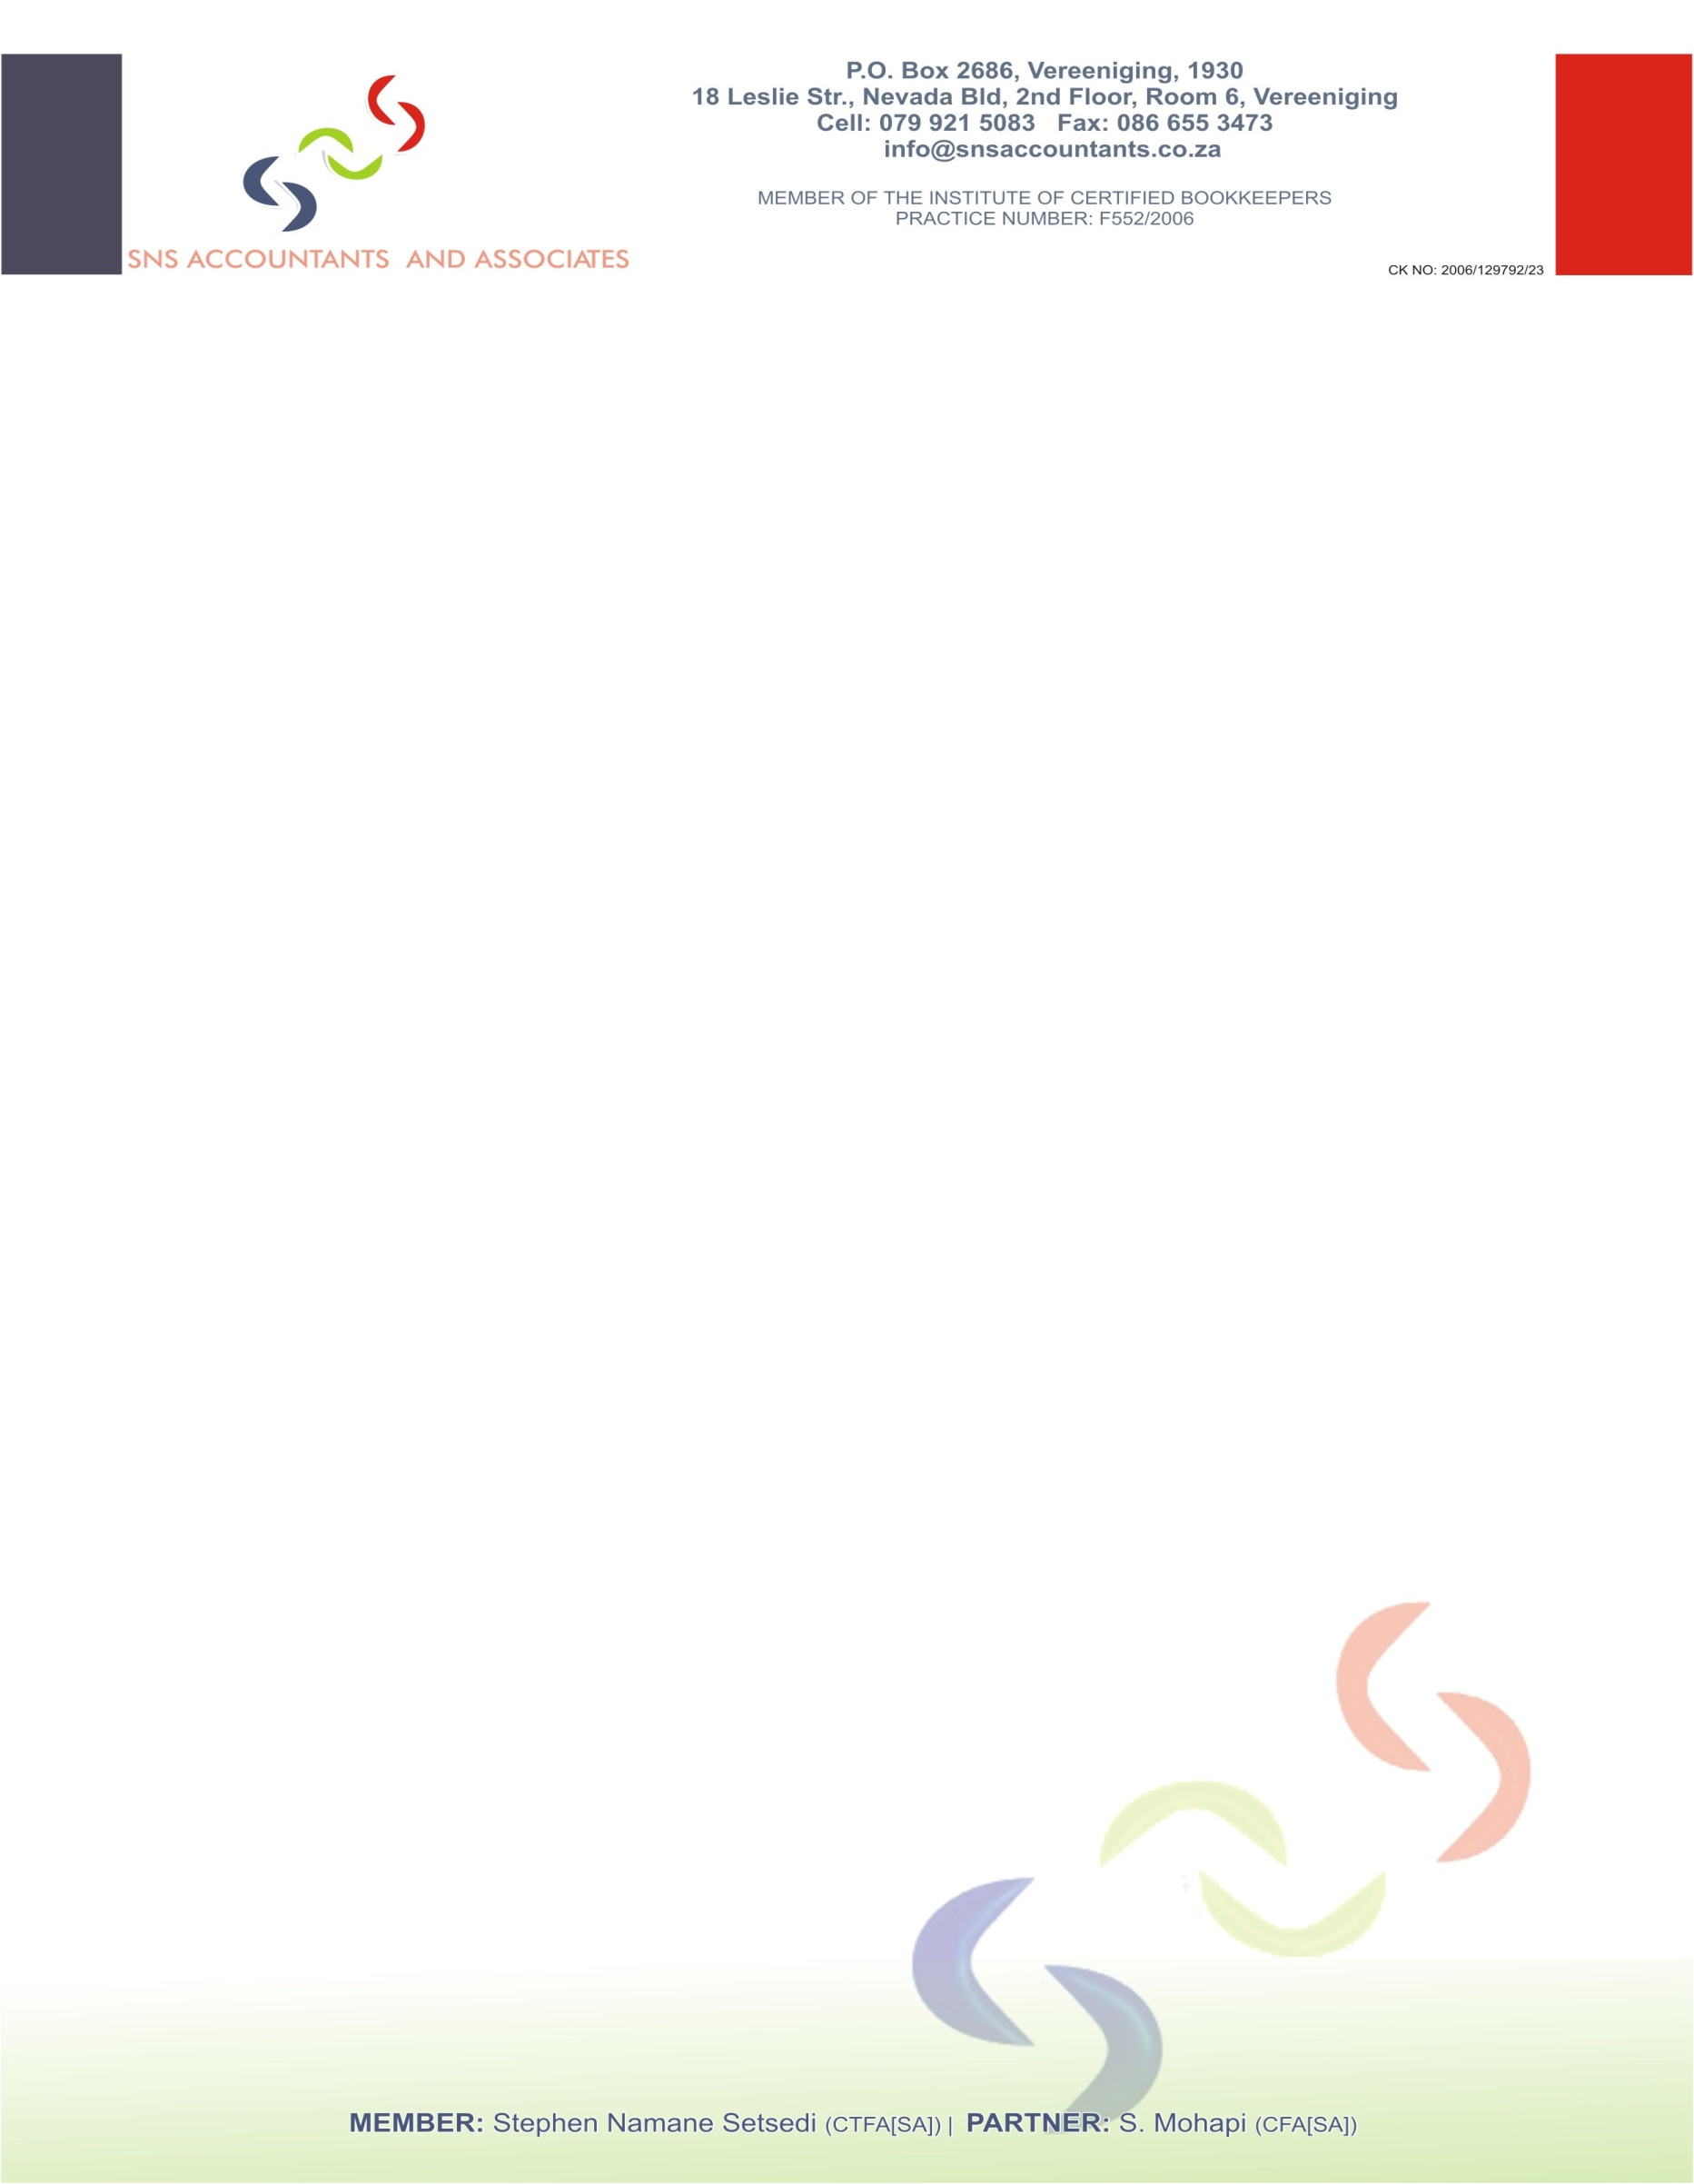
MEMBER OF SOUTH AFRICAN INSTITUTE OF BUSINESS ACCOUNTANTS (SAIBA)
PRACTICE NO: SAIBR 1534
---
40 JOUBERT STREET,VEREENIGING 1930
Tel (016) 422 3839 Cell: 082 958 7001
Fax: 086 547 5367
Email: nsetsedi@yahoo.com

GOZOLOLO CENTRE FOR NEEDY CHILDREN (SECTION 21)
AUDITED FINANCIAL STATEMENTS
PERIOD ENDED 28 FEBRUARY 2012

INDEX |  |  | Page
Report of Accounting Officer |  |  | 3
Balance Sheet |  |  | 4
Income Statement |  |  | 5
Notes |  |  | 6
Detailed Income Statement |  |  | 7
The Annual Financial Statements which appear on pages 3 to 7 were approved
by the management/trustee committee on 13 February 2015.
Signed By:
Chairperson: |  | Secretary:
MIRIAM P. CELE
_____________________________ |  | _____________________________
Treasurer:
SANDILE N. CELE

REPORT OF THE ACCOUNTING OFFICER
TO THE BOARD OF THE DIRECTORS OF
GOZOLOLO CENTRE (SECTION 21)
We have performed the duties of Accounting Officer to GOZOLOLO CENTRE FOR NEEDY CHILDREN (SECTION 21) for the year ended 28 FEBRUARY 2012
We have examined the books of accounts and vouchers of the board members and have obtained all the information and explanation which, to the best of our knowledge and belief, were necessary for the purpose of this examination.
In common with similar organisations, it was not possible for the Board Members
team to institute accounting controls over revenue and organisation funds prior to the initial
entry in the accounting records. Accordingly, it was impracticable for us to extend our
examination beyond the receipts actually recorded.
The annual financial statement set out on pages 2 to 7 are the responsibility of
management. We have determined that the annual financial statements are in
agreement with accounting records and have done so by adopting such procedures and
conducting such enquiries in relation to the books of account and records as we considered
necessary under the circumstances. We have also reviewed the accounting policies which
were presented to us as having been applied in the preparation of the annual financial
statements and we consider that they were appropriate to the organisation.
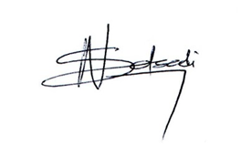
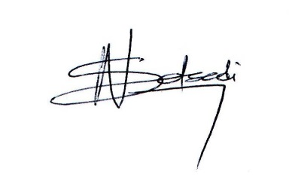
___________________________________
NS Setsedi
Accounting Officer
SAIBA: Practice Number SAIBR 1534
Date: 2015/02/13
Cell: 082 958 7001

BALANCE SHEET
 | Notes |  | 2012
FUNDS EMPLOYED
Accumulated Funds |  |  | 310 354.99
Total Funds Employed |  |  | 310 354.99
EMPLOYMENT OF FUNDS
Net Current Assets |  |  | 0.00
Current Assets |  |  | 310 354.99
Cash Equivalent |  |  | 310 354.99
Current Liabilities |  |  | 0.00
Accounting Fee Accrual |  |  | 0.00
Total Employment of Funds |  |  | 310 354.99

INCOME STATEMENTS
 | Notes | 2012
Total Income |  | 1 286 870.00
Total Operating Expenses |  | 976 515.01
Net Income / (Loss) |  | 310 354.99
Interest Paid |  | 0.00
Net Surplus / (Deficit) After Interest |  | 310 354.99
Opening Accumulated Funds |  | 0.00
Closing Accumulated Funds |  | 310 354.99

NOTES TO THE FINANCIAL STATEMENTS

1. Accounting Policies
The Income Statement and Balance Sheet were prepared on the historical cost.
Income and Expenses are recognised on the cash basis.
2. Turnover
Turnover is compromised of Income from activities and levies received. Income is recognised on a
cash receipts basis. Turnover is made up as follows:

Donations |  | 1282 209.00
Other Income |  | 4 661.00
Total Income |  | 1 286 870.00
3. Expenses
Accounting Fees |  | 3 600.00
Advertising |  | 1 596.00
Bank Charges |  | 10 111.00
Other Expenses |  | 961 208.01
Total Expense |  | 976 515.01
4. Bank Balances
ABSA BANK |  | 310 354.99
 |  | 310 354.99

DETAILED INCOME STATEMENTS
 | Notes |  | 2012
Income |  |  | 1 286 870.00
Donations |  |  | 1 282 209.00
Other Income |  |  | 4 661.00
Less Expenditure |  |  | 976 515.01
Accounting Fees |  |  | 3 600.00
Advertising |  |  | 1 596.00
Bank Charges |  |  | 10 111.00
Insurance |  |  | 6 584.00
Motor Repairs and Maintenance |  |  | 9 116.00
Salaries and Wages |  |  | 923 978.01
Stationery and Printing |  |  | 1 356.00
Rent, water and lights |  |  | 8 400.00
Telephone |  |  | 11 774.00
Net Surplus / (Deficit) |  |  | 310 354.99
Accumulated Funds - Beginning of the Year |  |  | 0.00
Accumulated Funds - End of Year |  |  | 310 354.99

